Words (meaning of the text)  The text occurs as a statement of the beliefs in God and the Trinity. When you speak this prayer, you are saying the you believe in the Holy Trinity and in the Catholic Church. It is another way to say the you believe in what God teaches. | Symbols (key themes of a text)
Pictures (the events described in a text) | The Nicene Creed is a statement of belief. It is another way to say that you believe in the Holy Trinity, and in what the Catholic Church does.  In the modern world, people believe in many things, for example, a soccer game. The supporters believe with all their heart that their team is going to win. They chant and yell war cries to show their support for the team.  This is sort of the same thing that Catholics say at church. They say that they believe in the Holy Trinity and what the Church Does.  Connections to Life (to a real life situation)
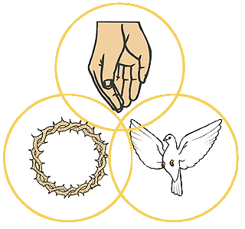
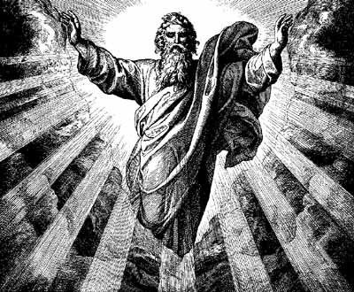
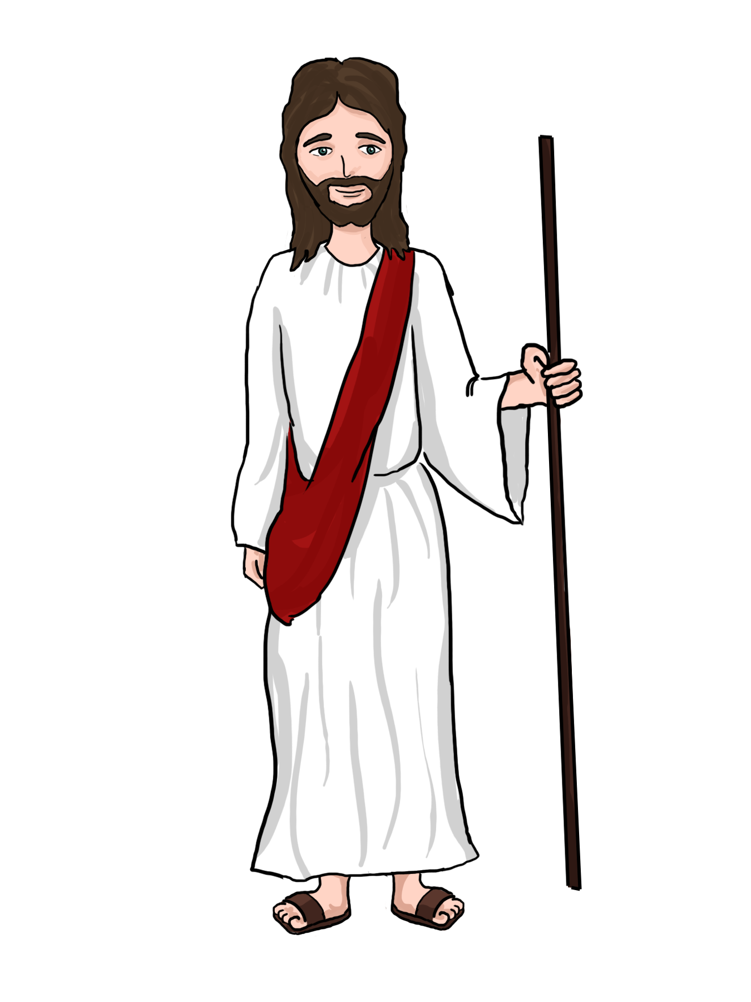
Think Pad Strategy: Nicene Creed
Father
Son
Holy Spirit
The Holy Trinity

